ANGLIA RUSKIN UNIVERSITY

RESUME MATCHING ONTOLOGY

BY
SID : 2241387
MODULE CODE:MOD004979

CONTENTS

INTRODUCTION --------------------------------------------------------------------------------------------- 3
CONCEPT/AIM ----------------------------------------------------------------------------------------------- 3
DESIGN--------------------------------------------------------------------------------------------------------- 4
EVALUATION/USE--------------------------------------------------------------------------------------------17
CONCLUSION--------------------------------------------------------------------------------------------------29
REFERENCES---------------------------------------------------------------------------------------------------30

INTRODUCTION
Semantic technology is a collection of methods that offer advanced approaches for filtering and classifying data and finding connections among diverse sources of information. An ontology is a collection of concepts and classifications within a field or subject that illustrates their characteristics and connections between events.
According to the World Wide Web Consortium's Semantic Web initiative, the goal of this technology within the framework of the Semantic Web's structure is to seamlessly connect the worldwide sharing of any type of personal, business, scientific, and cultural data to create a "universal medium for the exchange of data." Systems can integrate, process, and access information with greater efficiency whenever they use semantic graph databases(GraphDB from Ontotext). The Resource Description Framework (RDF), SPARQL (SPARQL Protocol and RDF Query Language), and OWL (Web Ontology Language) are the primary standards of Semantic Technologies. Businesses may find more intelligent data, deduce linkages, and extract knowledge from massive raw data volumes in a wide range of types and resources using the help of semantic technology. The main five components of ontology are classes, properties, individuals, and axioms.
The overall idea of the project is described in the Concept, Aim section. The protege's development is explained in the design section. This section provides an in-depth discussion of the classes, individuals, and their attributes. In the section on implementation, Explain how the application was made and the tools that were utilized for it. The Evaluation and Use section discusses the SPARQL queries and their methods for retrieving data from the ontology. This provides information about the application’s outcome.
CONCEPT/AIM
This project focuses on the method for matching resumes. Job advertisements have been plentiful online in recent years. Based on this, it will fit the resume of the applicant The goal of this project is to make it simple for the hiring staff to find all of the top applicants.
This project’s primary use is to compare job descriptions and resumes found on employment recruiting websites(like LinkedIn, Monster, and Indeed). The appropriate candidates will be identified depending on how well their skills match. Recruiters benefit from a resume-matching system, which suggests the best applicants for a given position. An applicant's skills and abilities are automatically matched to the skills a company needs for a particular job, which reduces the chance of errors when the procedure is carried out manually. It is generally used for the online screening process. Current algorithms match technical skills directly with keywords, which may overlook an applicant who precisely matches although missing the exact set of skills. Even though the e-recruitment platform is very extensive, it occasionally may turn away applicants by searching for people who are exactly matched and ignoring similarities.
An ontology was created by all the specifications stated to give the tools required to put in place a system that matches job descriptions with resumes. This ontology contains numerous employment sectors. The ontology is expanded to include education, work experience, and appropriate skills. These include personal details about the candidate. All of the candidates who fit the job descriptions will be shown because of the SPARQL searches.

DESIGN
This ontology consists of 1314 axioms, 51 classes, 11 object properties, 7 data properties, and 208 individuals.
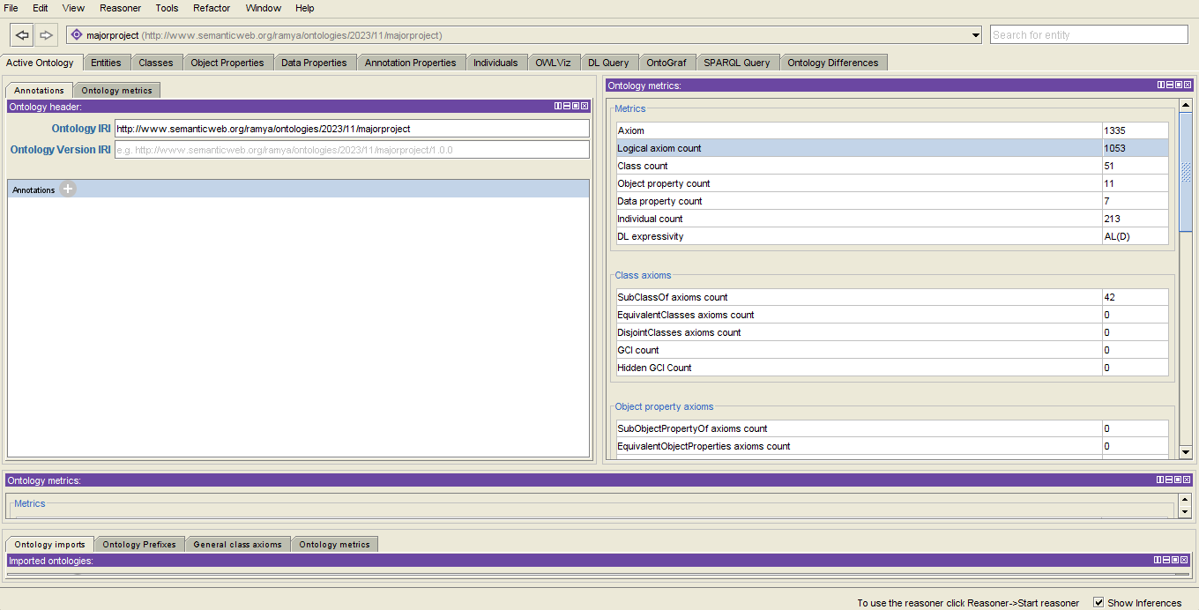
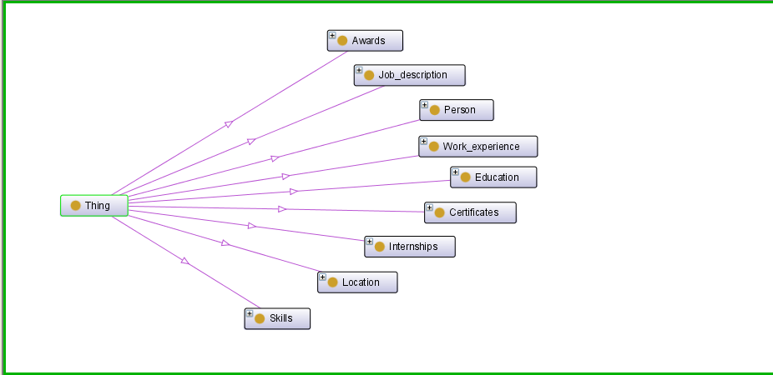

These are the classes that the ontology has available. Person, Job_description, Location , Skills , Internships, certificates, education, work experience, and Awards.

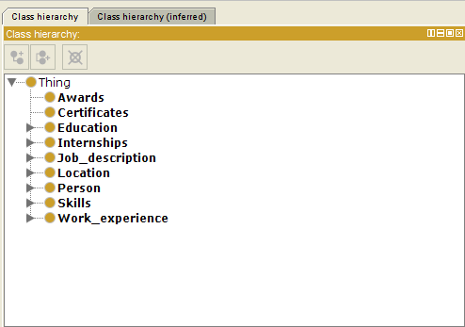
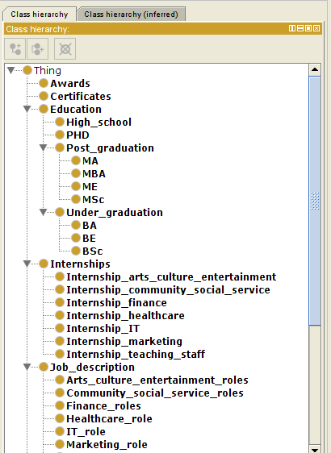

The class Job_description comprises seven subclasses. Within this ontology, there are seven distinct job sectors. The Arts culture entertainment job sector includes with job listings for photographers, dancing instructors, singers, and many more. Professions under caregiving and healthcare administration are included in the community and social service sectors.The aim of developing so many diverse employment sectors is to enhance the size of the ontology, thereby rendering it valuable and accessible to a wide range of users.Accountants, budget analysts, as well as additional individuals who work in finance. All of the top recruiting employment jobs in the corresponding fields are included in this ontology. The field of information technology is broad enough to offers a variety of opportunities. Numerous subgroups inside each of the IT areas make up this ontology. Engineers in machine learning, artificial intelligence, software development, web development, front end and back-end engineer, and many more.
This system matches job descriptions with resumes, considering various criteria consist of skillsets, education, work-experience as well as personal details.
To achieve this, I structured an ontology that includes classes such as job descriptions, internships, education, skills, and personal details. Each class contains specific attributes and subclasses to capture nuanced information. For instance, within the education class, I included categories for post-graduate (PG), undergraduate (UG), and high school education, along with their respective subgroups. This granularity is crucial as job requirements often vary, and having detailed educational information aids in better matching.
The system uses a matching algorithm that matches the attributes and data given in the job advertisement with those present in the resume. It assesses the relevance and compatibility of skillset, work experience, and educational achievements mentioned in the resume to the job requirements outlined in the job advertisement. By employing, the system efficiently identifies the appropriate applicant for specific job roles.
The goal of the ontology is to streamline the recruitment process by automating the initial screening phase. This not only saves time but also ensures that potential candidates are more appropriately selected based on their achievements and competencies as per the need.
The system's ontology is regularly updated to accommodate changes in various job sectors corresponding job advertisements. This ensures that the system remains adaptable and effective in accommodating evolving industry standards and job demands

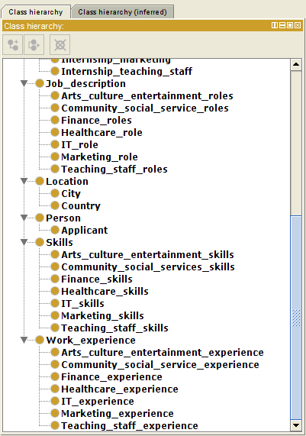

The properties mentioned are vital aspects in evaluating employment advertisement and applicant achievements. "graduated_as" defines academic achievement, while "has_awarded" and "has_certifications" highlight accolades and professional validations. "has_experienced_as" and "has_internship_experience" signify work and practical exposure. "has_skills" is crucial for skill matching. "lives_in" denotes the location. "require_education" and "require_workexperience" outline job prerequisites. "require_skills" specifies needed competencies. These attributes bridge job criteria and applicant capabilities. They contribute to a comprehensive evaluation applicant applying for roles, ensuring a suitable description of the employment and applicant qualifications.

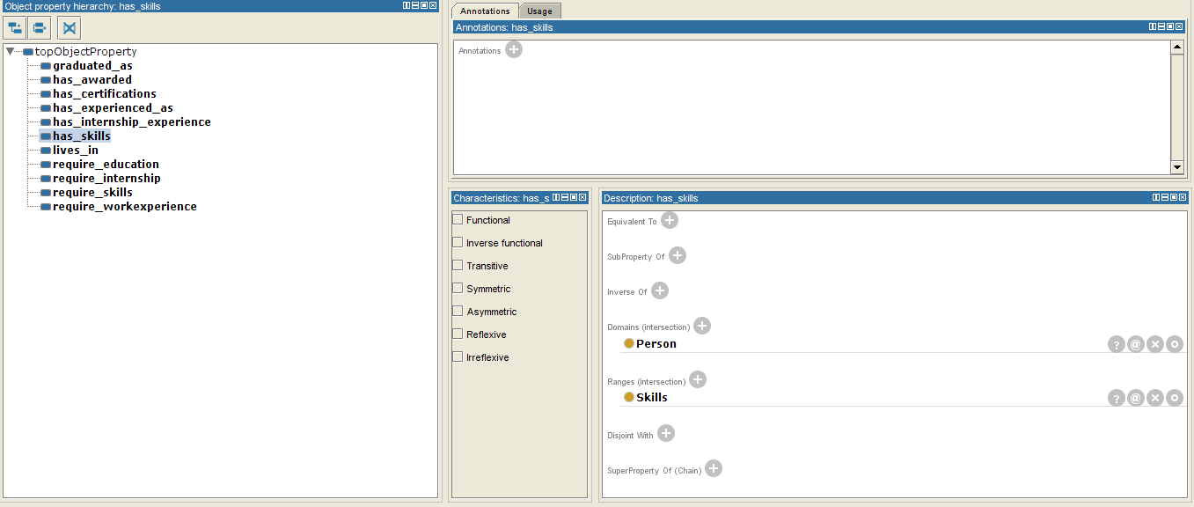

These data properties hold essential information: "age" refers to the candidate's age, "gender" denotes the person's gender identity, "email" is the candidate's email address, "name" is the individual's name, "salary" signifies the offered pay, "years_of_experience" represents the candidate's professional background, "internship_time_limit" sets a duration for internships. These elements play a pivotal role selecting work descriptions and applicant profiles, ensuring a suitable applicant with correct qualifications.

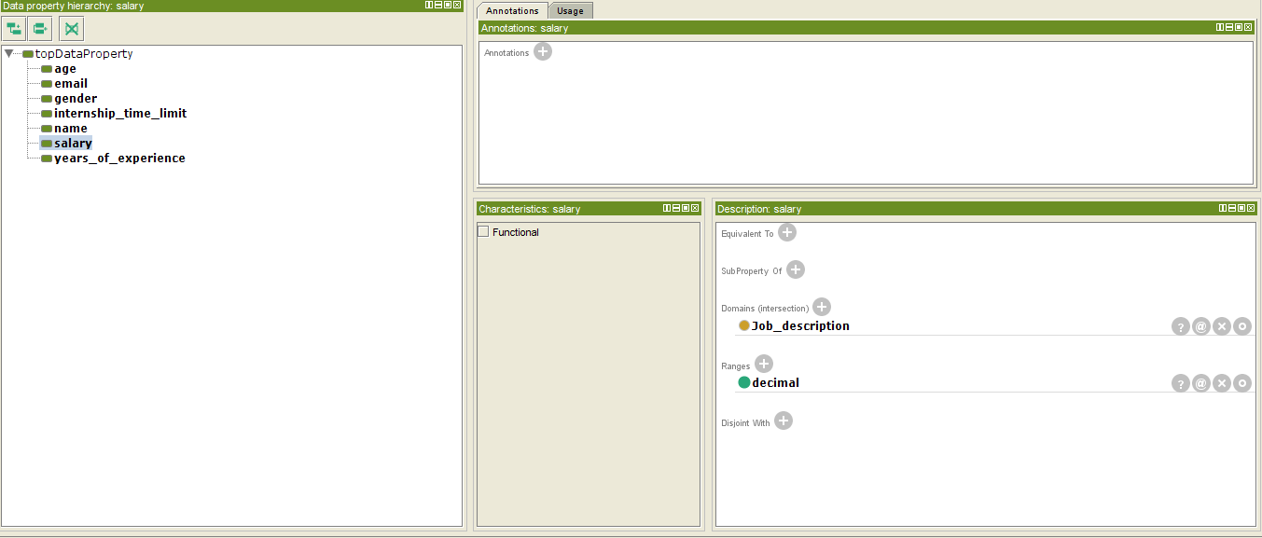



The dataset includes detailed profiles of more than 200 individuals incorporating their personal data and specific job descriptions this information has been methodically integrated into the ontology covering a wide range of attributes such as personal details and detailed job descriptions this robust collection within the ontology enables thorough analysis and effective matching between candidates and job criteria.




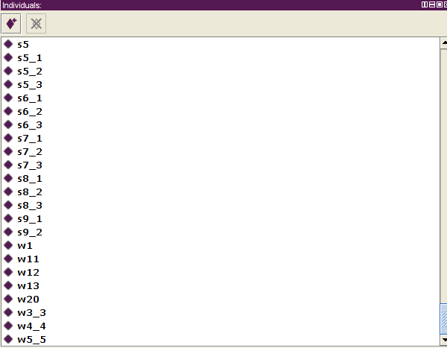

Ontograph is the presentation of ontology helping in organising and displaying intricate datasets in this scenario ontography serves as a subset within the ontology focusing on a dataset that includes job advertisement it visualises connections and arrangements present in the job advertisement dataset aiding in understanding and analysis

The ontograph displayed below explains the Job Description. It displays all the individuals and subclass of that particular ontograph. The next ontograph is the Work Experience. Then the basic structure of the ontology is described using the ontograph.A person’s ontograph has been explained in this section

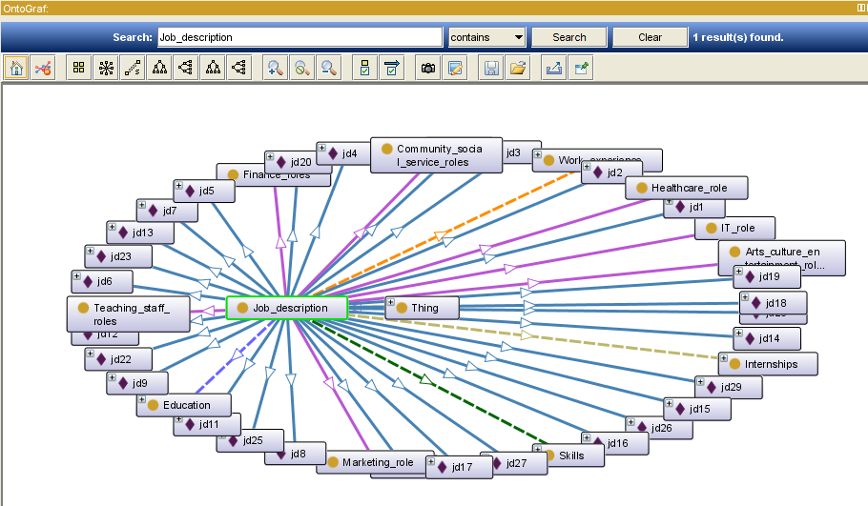

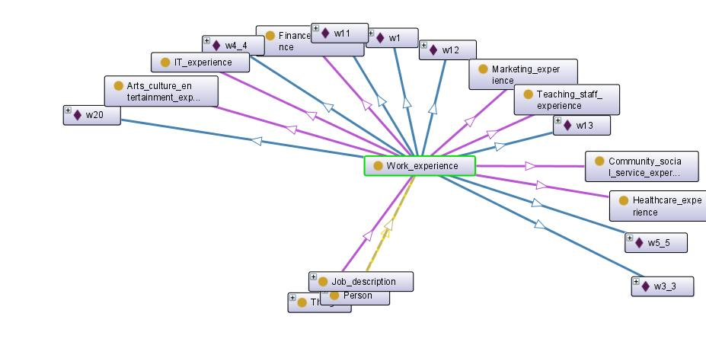

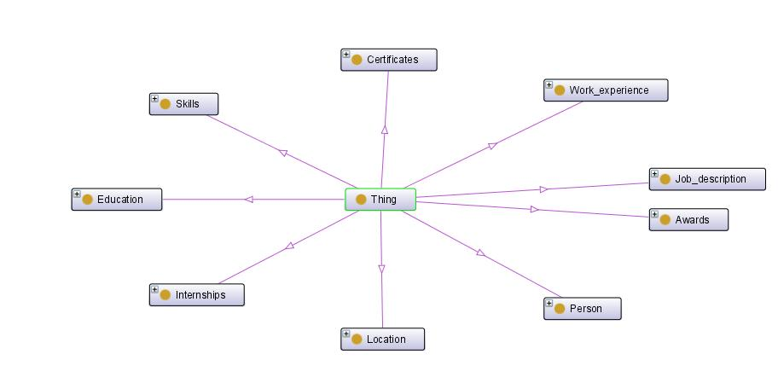
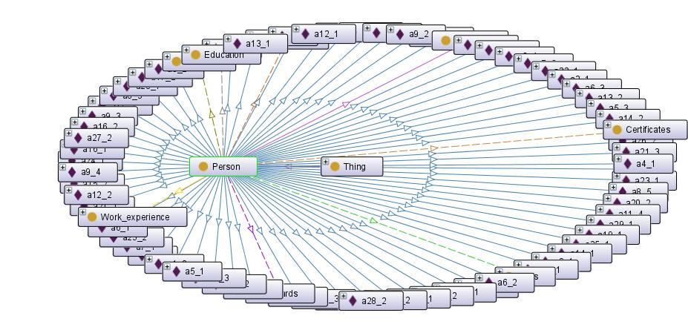

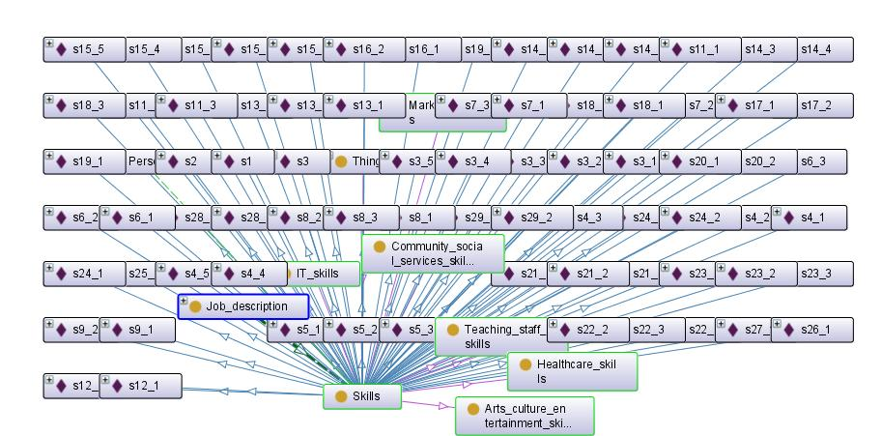

EVALUATION/USE
Sparql deals with rdf data using a language structure that takes after sql enabling clients to show plans inside the data they need to recuperate questions are molded using plans that depict the design of rdf data counting subject-predicate-object significantly increases these inquiries can incorporate essential recuperation complex sifting and gatherings why sparql has a basic influence inside the semantic web by publicizing a normalized methodology to recuperate and request data from rdf data sets it gives a method for gaining to and influence coordinated and interconnected data engaging semantic looks and empowering data mix over unmistakable sources when sparql is used in various situations for example data joining associated data examination data graph addressing semantic look engines and applications requiring semantic data recuperation its applications stretch out from the academic local area to organizations making do with associated data and semantic advancements in frame sparql empowers clients to recover explicit information from rdf datasets engaging semantic addressing and data command over various spaces and applicat
Displaying the names, ages, and genders of individuals using the SELECT and WHERE clauses, with a limit of 10 results.

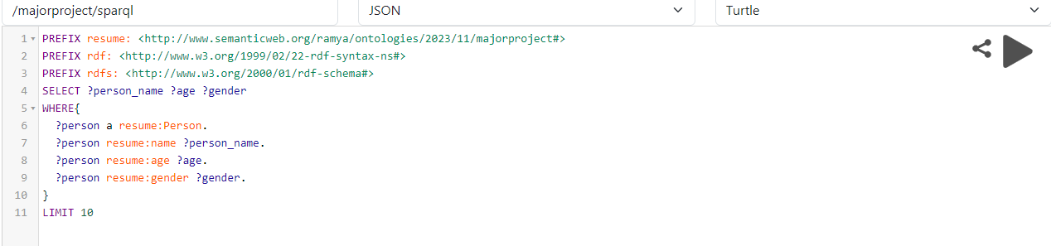

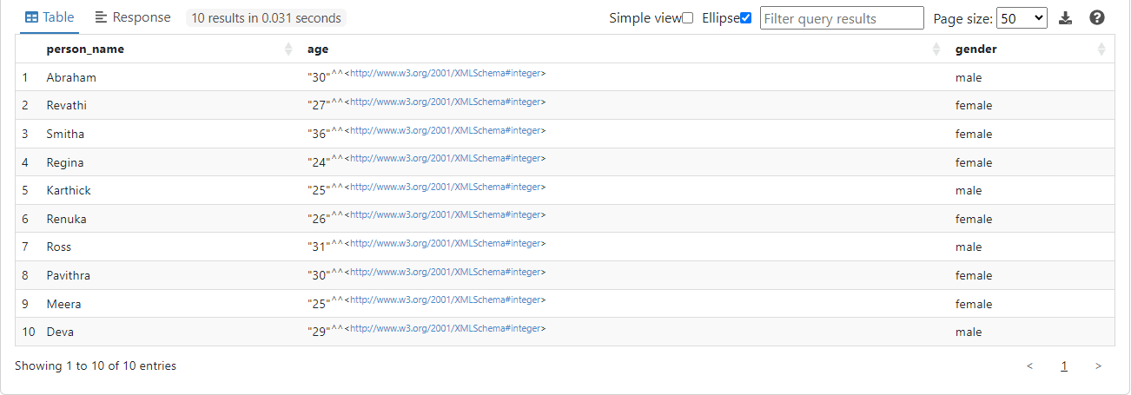

Filtering and Displaying information by matching a person's skills ("has_skills") with the required skills in job descriptions ("require_skill"). This includes showing the person's name ("person_name") alongside the job descriptions where the skills match.

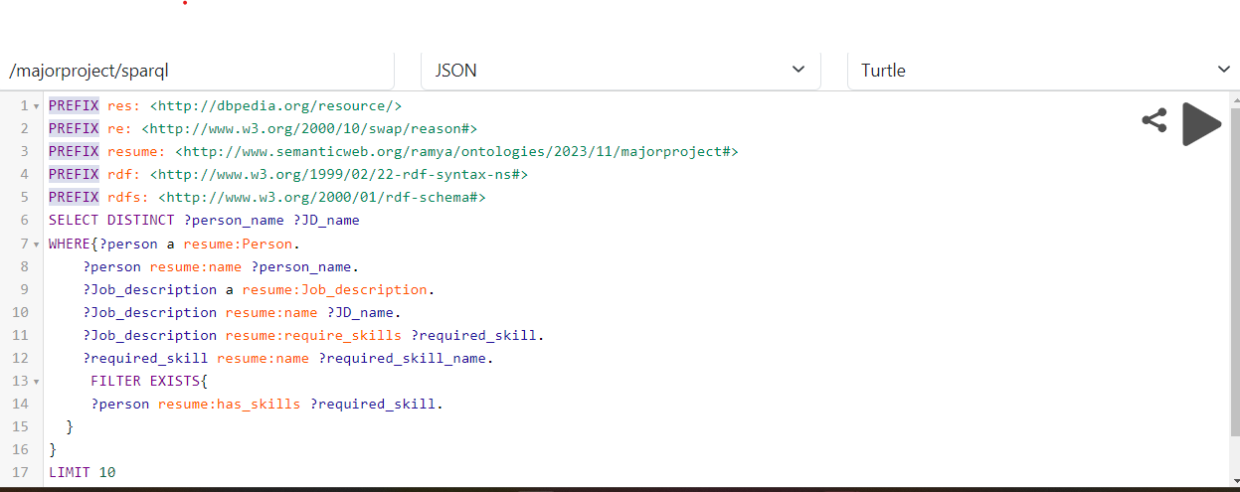
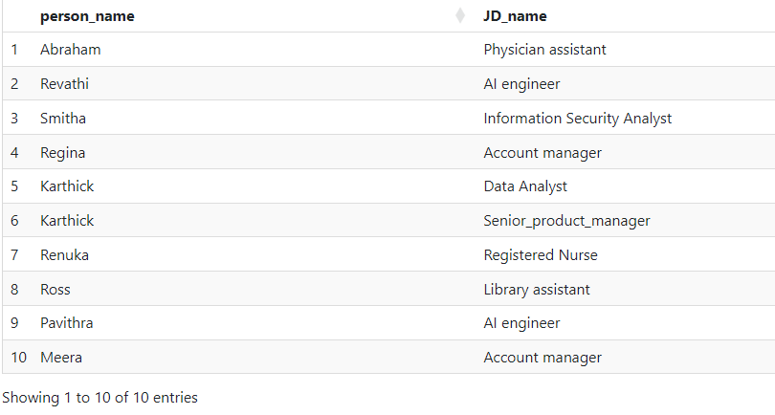

Based on the bind , groupby displaying a salary range which takes salary between 10000-20000 as one group , salary between 20000-30000 as the other group. Then combining the result using GROUP BY

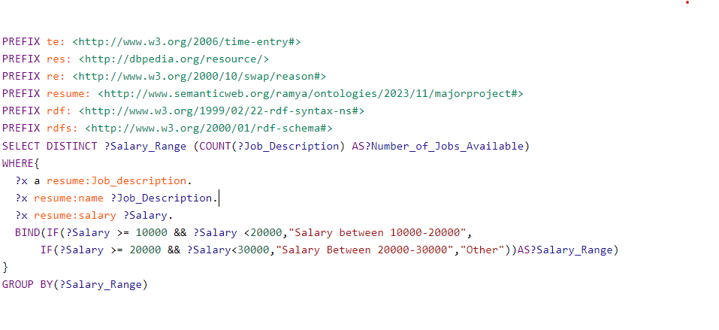
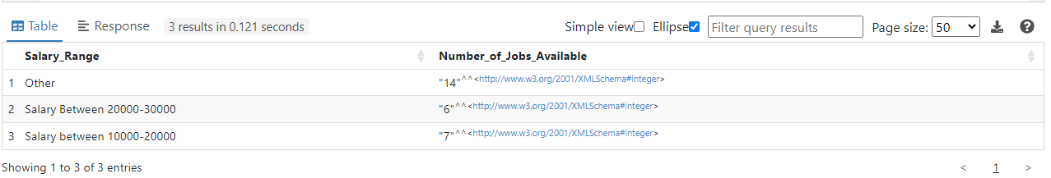

To showcase undergraduadte student by utilizing the bound method one can filter and extract candidate profiles where the internshipexperienced attribute holds a specific value or meets particular criteria this method calcultes precise selection and displays individual who possess internship experiences in their profiles
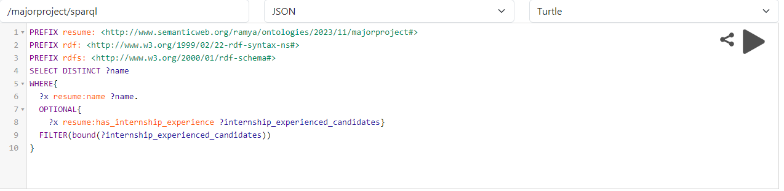

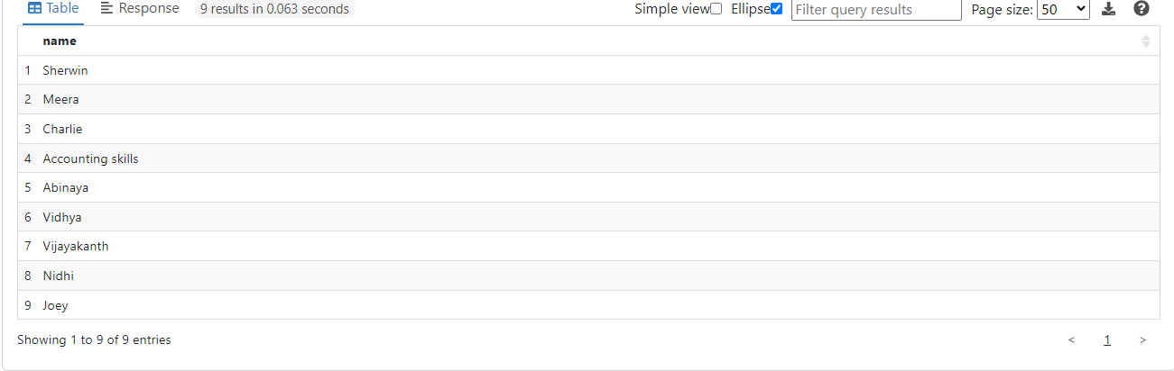

This query will display all the applicants who matches the job description’s education and skills. This query uses the CONCAT , GROUPBY , FILTER and WHERE. This checks the matching of has_skills and require_skills . This also checks the require_education and graduated_as object properties. Here the result will display only 20 values as there is a LIMIT function

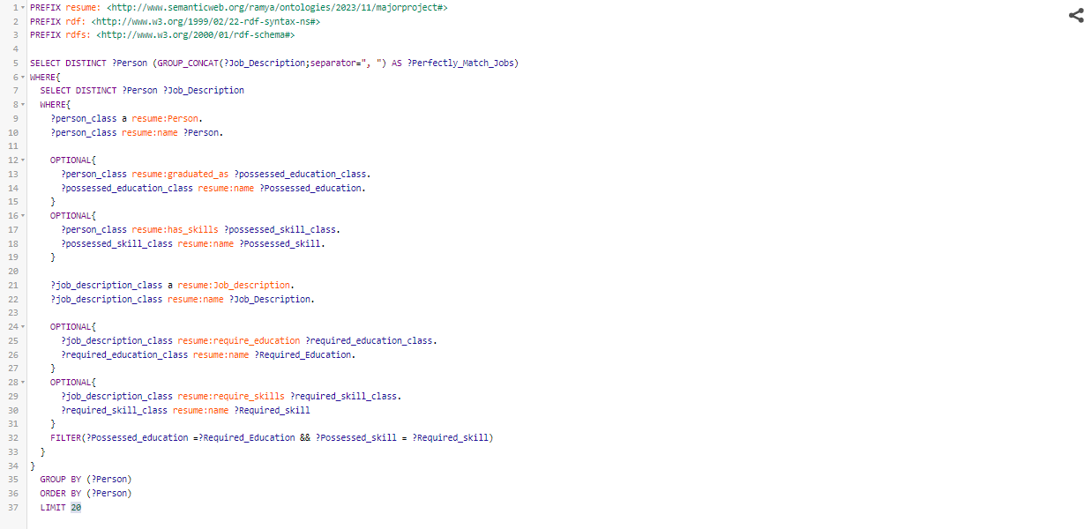

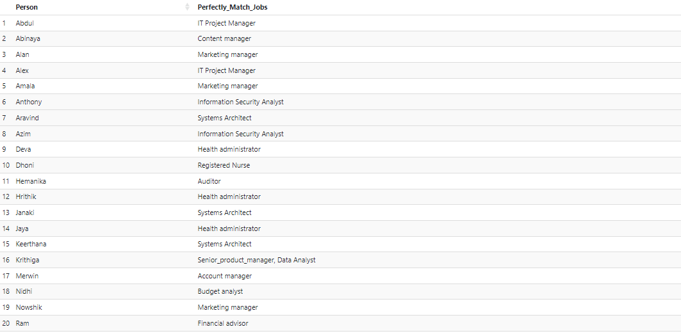

This is the working of the Natural Language processing . The working of these lines are explained as a commands. This uses spacy and SPARQLWrapper. The queries are also explained in the code.

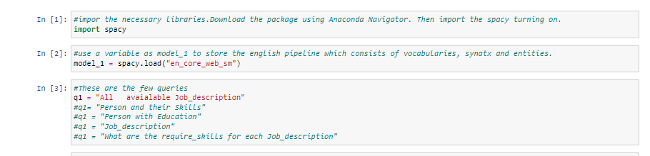
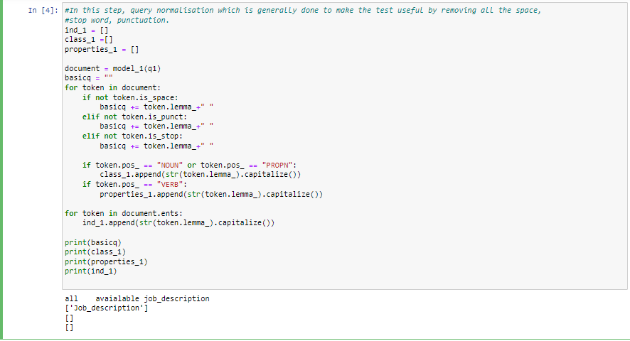
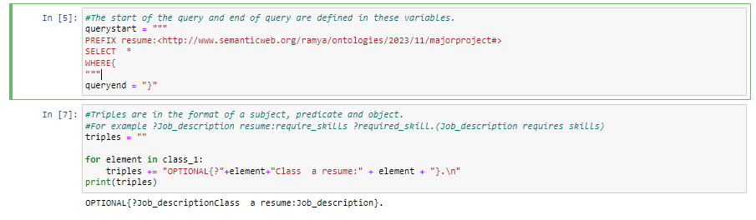
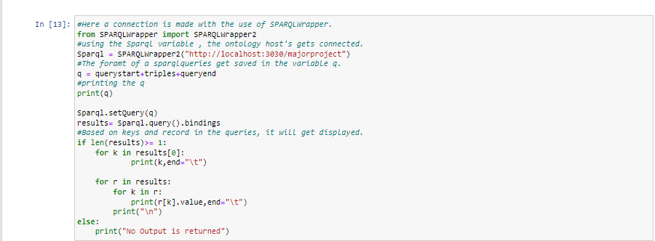
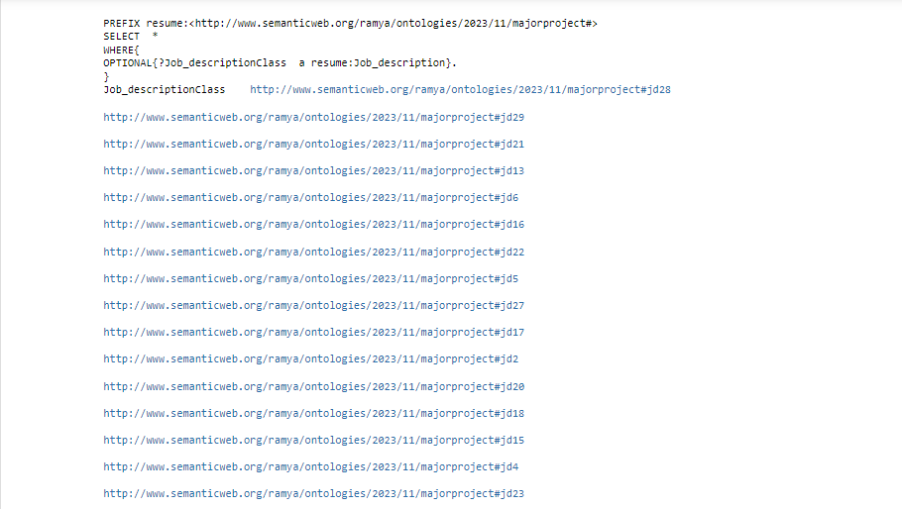


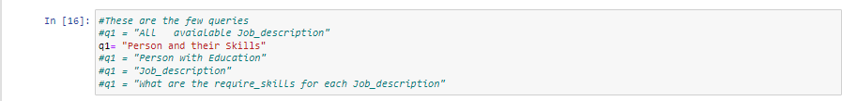

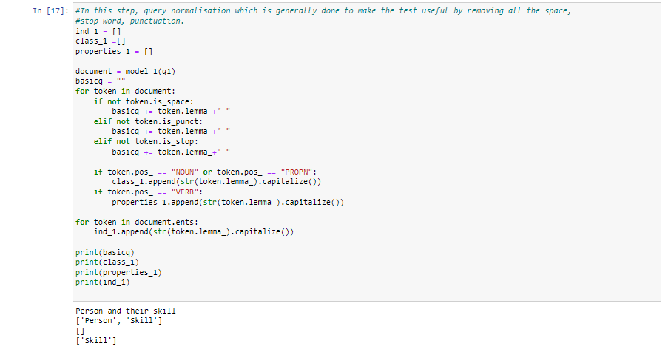

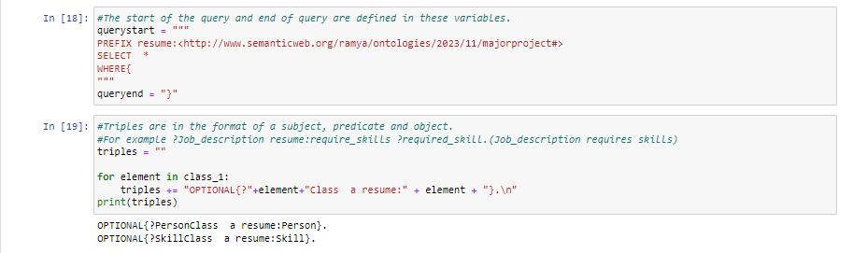
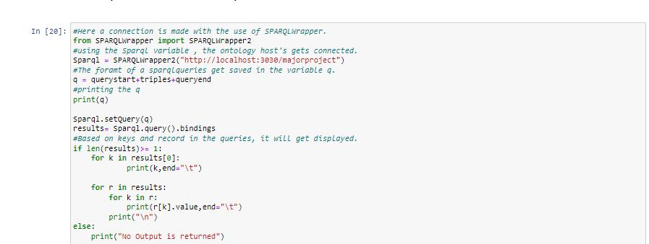

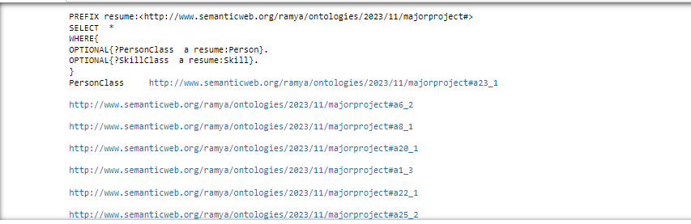

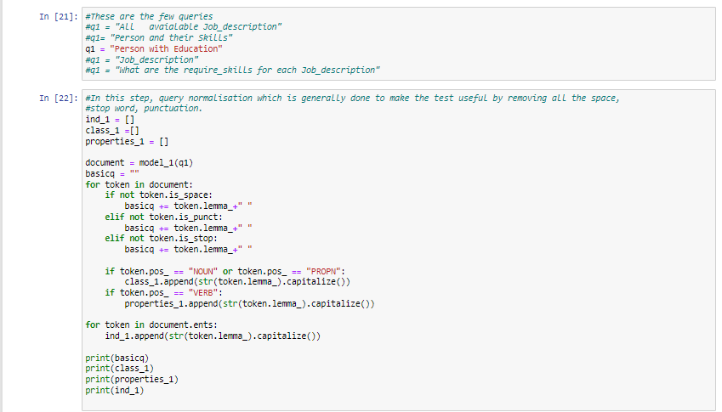

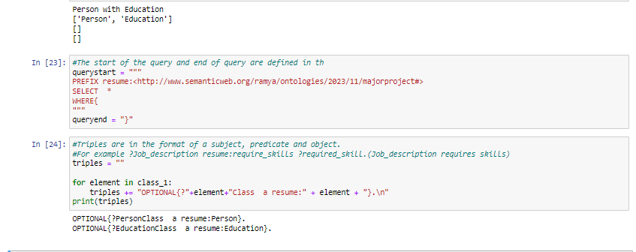

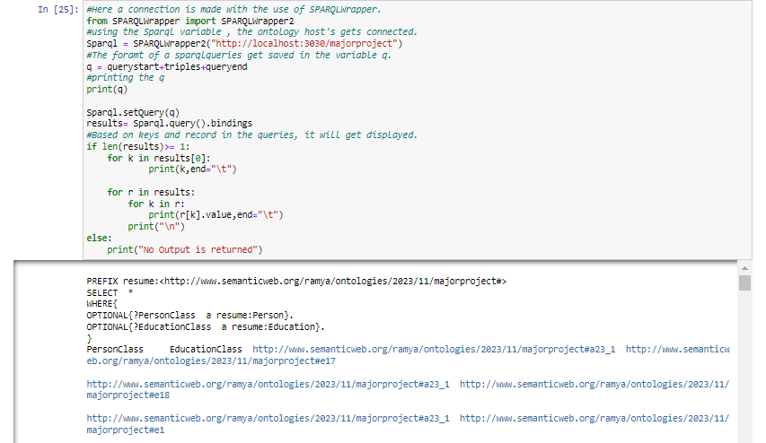

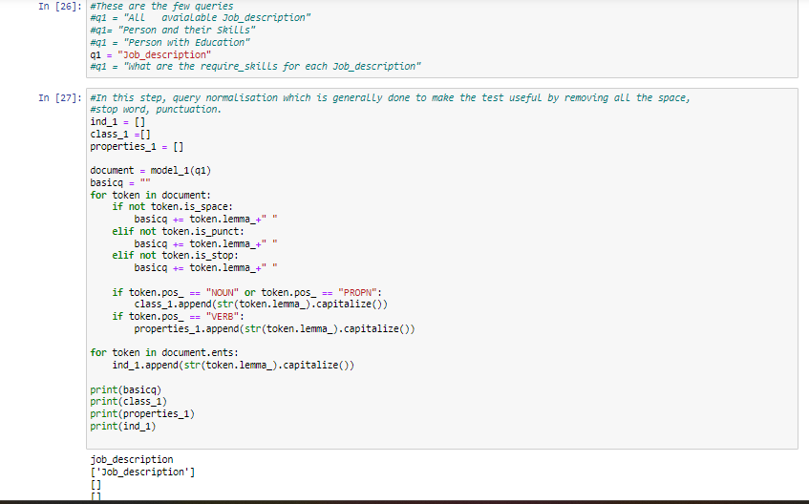

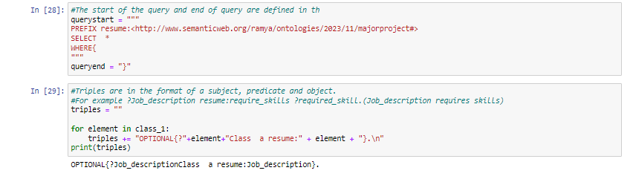
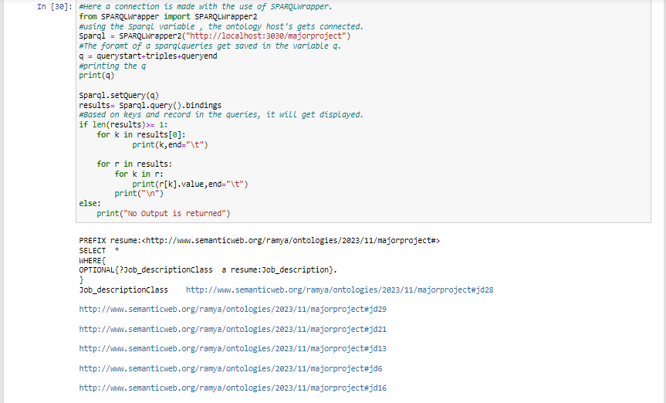

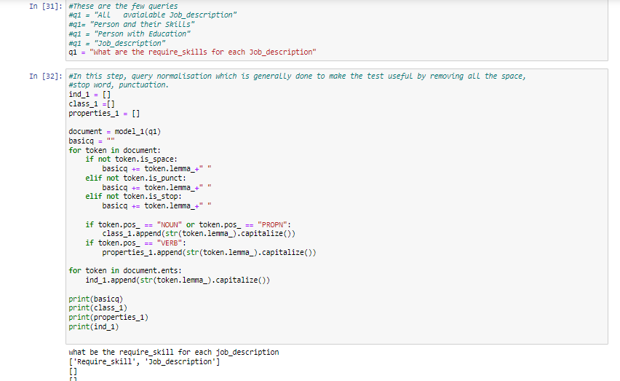

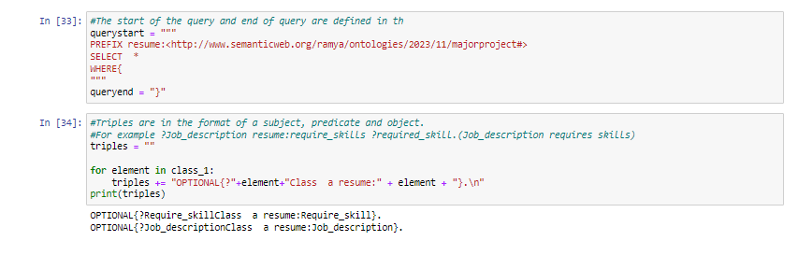
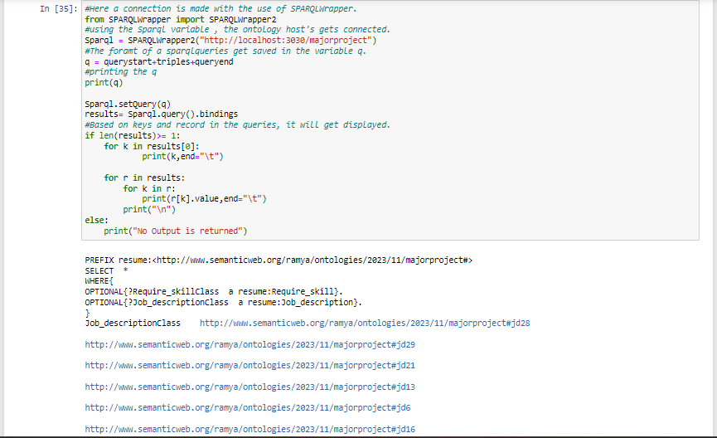

CONCLUSION
In summary, we can say that the implementation of semantic analysis in CV matching has proven to be a central tool in the modern selection process, where using advanced tech and semantic algorithms, The productive and best candidate selection is significantly increased by comprehensively interpreting the semantic context of resumes. This approach improves jobs understanding and input and applicant qualifications. It not only streamlines talent acquisition, but also ensures alignment between candidates and roles, resulting in better hiring results.As technology advances, continued advances in semantic analysis are expected to further refine recruitment approaches, providing better matches and faster hiring processes.

REFERENCES
ieeexplore.ieee.org. (n.d.). An Ontology-Based Approach for the Semantic Representation of Job Knowledge | IEEE Journals & Magazine | IEEE Xplore. [online] Available at: https://ieeexplore.ieee.org/abstract/document/7140782?casa_token=_A6oHELbSIMAAAAA:tzK_YF4d9sybi2noJKWEqM979CWHUHtsdo-SKPRRhowMCb1xbNGDdjiHBVkwWXFY8hpdouqG [Accessed 20 Nov. 2023].
ieeexplore.ieee.org. (n.d.). An Ontology-Based Approach for the Semantic Representation of Job Knowledge | IEEE Journals & Magazine | IEEE Xplore. [online] Available at: https://ieeexplore.ieee.org/abstract/document/7140782?casa_token=_A6oHELbSIMAAAAA:tzK_YF4d9sybi2noJKWEqM979CWHUHtsdo-SKPRRhowMCb1xbNGDdjiHBVkwWXFY8hpdouqG [Accessed 20 Nov. 2023].
ieeexplore.ieee.org. (n.d.). An Ontology-Based Approach for the Semantic Representation of Job Knowledge | IEEE Journals & Magazine | IEEE Xplore. [online] Available at: https://ieeexplore.ieee.org/abstract/document/7140782?casa_token=_A6oHELbSIMAAAAA:tzK_YF4d9sybi2noJKWEqM979CWHUHtsdo-SKPRRhowMCb1xbNGDdjiHBVkwWXFY8hpdouqG [Accessed 20 Nov. 2023].
Martinez-Gil, J., Paoletti, A.L. and Pichler, M. (2019). A Novel Approach for Learning How to Automatically Match Job Offers and Candidate Profiles. Information Systems Frontiers. [online] doi:https://doi.org/10.1007/s10796-019-09929-7.
Fazel-Zarandi, M. and Fox, M. (n.d.). Semantic Matchmaking for Job Recruitment: An Ontology-Based Hybrid Approach. [online] Available at: http://www.eil.utoronto.ca/wp-content/uploads/km/papers/fazel-sm09.pdf [Accessed 30 Nov. 2023].
Yi, X., Allan, J. and Croft, W. (n.d.). Matching Resumes and Jobs Based on Relevance Models. [online] Available at: https://maroo.cs.umass.edu/getpdf.php?id=747 [Accessed 8 Dec. 2023].

